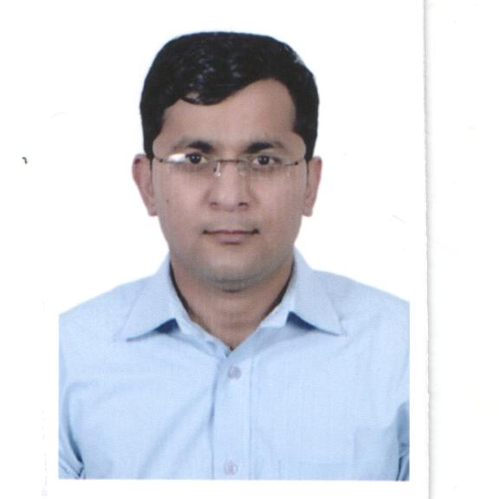

CURRICULUM VITAE

PANKAJ BAHRI | House No. N.K. 84 Bazaar Nauhrian  Jalandhar City, Punjab  Ph. 0181-2403926 , 9023571358.  E-mail : pankajbahri1983@yahoo.co.in

Personal Details

Father’s Name : Mr. Harinder Kumar Bahri

Mother’s Name : Mrs. Vinod Bala
Date of Birth : 30.11.1983
Sex : Male
Marital Status : Married
Proficiency in Languages : English, Hindi, Punjabi
Nationality : Indian

Career Objectives

To be dynamic & learning till I breath my last. To have a challenging career which demands accountability, has a result oriented approach, requires an innovative professional acumen and provides conductive growth opportunities compatible with my capabilities.

Key Strengths & Achievements

- To boost up sales & got it award across circle in RWSL.
- For Enhancement of sales/profitability with appointing new C & F Agents/OEM Involvement. Adaptable & Hardworking.
- Team Player & Effective Leadership Qualities.
- Good Analytical & Communication Skills.

Academics

Year | Curriculum | University / Institute | Marks
June, 1998 | 10th | P.S.E.B. | 64%
June, 2000 | 10+2 (Commerce) | P.S.E.B. | 58%
April, 2003 | B.Com. | G.N.D.U. , Amritsar | 56%
May, 2005 | M.A. Economics | G.N.D.U. , Amritsar | 58%

Skills

An Experienced with ability to initiate/manage the cross functional team & multi disciplinary projects.Haivng knowledge of Computer Education, Internet & POS software’s completely.

Professional Diploma :

Completed one Year Post Graduate Diploma in Retail Management from SCDL (Symbiosis Center of Distance Learning) PUNE.

Work Experience

I had worked with M/s Y.K.SUD & Co. (Chartered Accountants) as Audit assistant for 1 year.
I have also worked with Ashirwad Enterprises (Hutch Distributor) as a Backend Incharge for a Period June 2005 To August 2006.
I had worked with Reliance World (Jalandhar, Model Town) As a Operational Executive for a period Aug 2006 to May 2010

Job Profile at Reliance World
- Worked as an OE.
- Store Staffing n Scheduling
- Retail Floor & Shelf Management.
- Store Administration & Achieving Sales Targets in Both Depts. ( C 3 & BBC)
- POS/Cashiering Process
- Visual Merchandising.
- Making various MIS like Daily Business Report for C 3 as well in BBC
- Generating PIS & Bank Reconciliation.
- Managing store Assets & Store profitability Report.

Presently, I am working with Sharp Group of Industries, Jalandhar as a Assistant Manager – Sales & Operations w.e.f 27/05/2010.

Company profile: Company is into manufacturing of Lead Acid Batteries (SHARP)
since 1980 (Based at Jalandhar – Punjab)

Job Profile at Sharp Industries: Look in to Sales and Operations.

- Manage region’s C & F, Distributor & their concerned.
- Leads and co-ordinates with Sharp Team and responsible for the Region’s forecasting and sales tracking.
- Evaluate market trends and gather competitive information, identify trends that effect current and future growth of regional sales and profitability.
- Managing a team of customer services staff.
- Investigating and solving customers' problems, which may be complex or long-standing problems that have been passed on by customer service assistants.
- Handling customer complaints or any major incidents, such as a Claim issue or a customer being taken ill.
- Visiting customers to provide a one-to-one service.
- Developing feedback or complaints procedures for customers to use.
- Developing customer service procedures, policies and standards for organization or department.
- Being involved in staff recruitment and appraisals.
- Training staff to deliver a high standard of customer service.
- Establishes an environment and foundation for future sales growth Marketing and Advertising program design and execution with own brand and for OEM Sector as well. Sales and distribution planning.

Date 28th March 2015 Place: Jalandhar (PANKAJ BAHRI)

